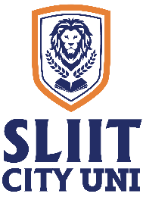
SLIIT CITY UNI

Final Examination Timetable – On Campus

Year 1 – Semester 1, December 2024

2024 June Intake
Higher Diploma in Information Technology

Date | Time | Subject
09/12/2024 | 1.30 p.m. – 3.30 p.m. | Business English & Communication Skills (IT1104) (Written)
11/12/2024 | 9.30 a.m. – 11.30 a.m. | Introduction to Programming (IT1103) – Session 1 (Online)
 | 12.00 noon – 2.00 p.m. | Introduction to Programming (IT1103) – Session 2 (Online)
13/12/2024 | 2.00 p.m. – 4.00 p.m. | Data Communications and Computer Networks – I (IT1106) (Written)
16/12/2024 | 1.30 p.m. – 4.30 p.m. | Mathematics for Computing (IT1105) (Written)
18/12/2024 | 1.30 p.m. – 4.30 p.m. | Computing Fundamentals (IT1111) (Written)

Academic Affairs Division
Date: 30 November 2024

