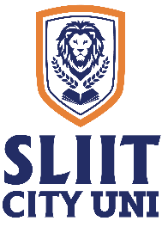
SLIIT CITY UNI

Final Examination Timetable – On Campus

Year 1 – Semester 1, December 2024

2024 June Intake
Higher Diploma in Business Management

Date | Time | Subject | Venue
08/12/2024 | 9.30 a.m. – 12.30 p.m. | Business Mathematics (BM1110) (Written) | 12th Auditorium
09/12/2024 | 1.30 p.m. – 3.30 p.m. | Business English & Communication Skills (IT1104) (Written) | Same as for HDIT
11/12/2024 | 9.30 a.m. – 12.30 p.m. | Business Economics I (BM1108) (Written) | HN 607
13/12/2024 | 9.30 a.m. – 12.30 p.m. | Management Principles (BM1102) (Written) | HN 607
16/12/2024 | 1.30 p.m. – 4.30 p.m. | Financial Management (BM1109) (Written) | HN 505

Academic Affairs Division
Date: 02 December 2024

