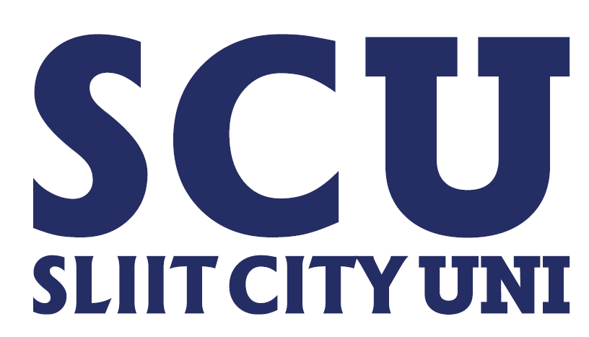
Medical Submission Form
Program & Semester: Year 02 – Semester 02 (HDIT / HDBM)
Examination: Final Examination
Intake: October 2024

Instructions for Submission:
- Eligibility for Submission:
Students who are unable to attend the examination due to medical reasons must submit an acceptable Medical Certificate(s) covering the period of absence. This must be submitted within 24 hours from the date of the examination or from the examination of the relevant module(s), as applicable.
- Submission Requirements:;
  - Medical Certificate(s): The certificate must be issued by one of the following:
    - Government Medical Hospitals
    - Medical Practitioners certified as authentic by the SLMC

  - Completed Application Form: The form below must be duly filled out and submitted along with the Medical Certificate(s).
  - Form Link: https://forms.gle/hBruHPtFeDqM1wN59
- Concessions for Medical Grounds:
Students whose Medical Certificates are deemed acceptable will be eligible for an ‘IC’ (Incomplete) grading. This grade allows students to reattempt the examination as a first attempt student and obtain the applicable grade based on their next attempt.
- Next Examination Registration:
Students must make the necessary registration for the next examination through the official process, which may require payment.
Student Affairs Division
06/09/2025

